Android Exercises

Menus, Dialogues and Notifications in Android

**Menus** are an important part of any application. They provide familiar interfaces that reveal application functions and settings.

**Menu** is an efficient and friendly way to display multiple options, from which users can choose what they like.

* **Option Menu** - **Android Option Menus** are the primary menus of android. They can be used for settings, search, delete item etc.
* **Context Menu -** Android context menu appears when user press long click on the element. It is also known as floating menu. It doesn't support item shortcuts and icons.
* **Popup Menu -** Android Popup Menu displays the menu below the anchor text if space is available otherwise above the anchor text. It disappears if you click outside the popup menu.

**Exercise on Android Options Menu:**

We are inflating the menu by calling the **inflate()** method of **MenuInflater class**. To perform

event handling on menu items, you need to override **onOptionsItemSelected()** method of

Activity class.

1. Create a new project and name it as “Menu Application”

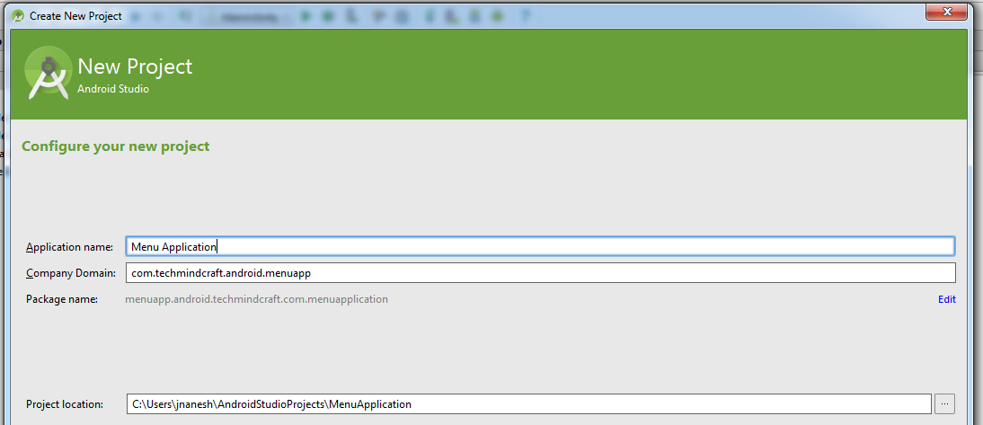

1. Enter the Activity Name as “OptionMenuActivity”, Layout Name as “activity_option_menu” and Title as “Option Menu Screen”

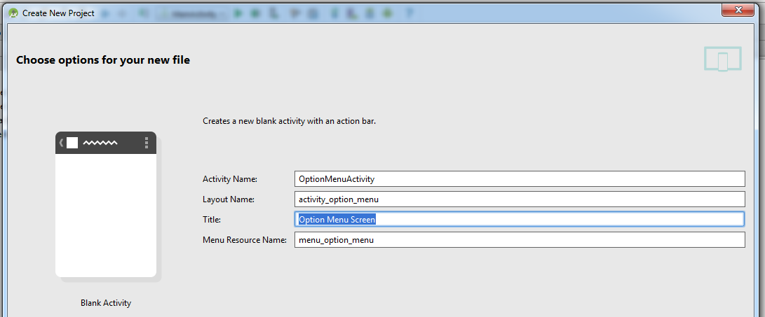

1. Expand the “res” folder and then “menu” folder, select “menu_option_menu.xml” file :

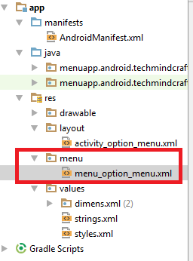

1. In your “menu_option_menu.xml” add 3 Items as described in the below xml code:

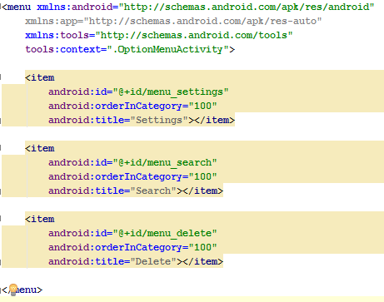

1. In your “OptionsMenuActivity.java” add the following code to see the option menu functions.

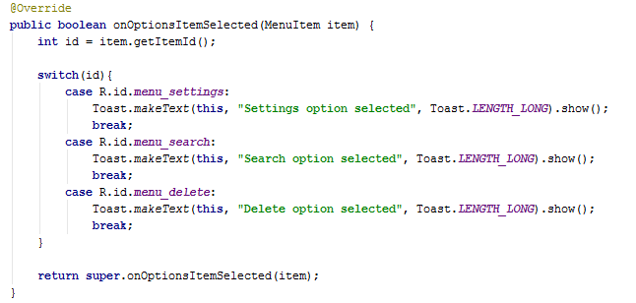

1. Run the application and click on menu icon as described below:

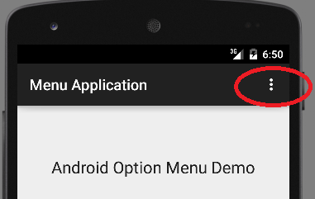

1. You will be able to see the below output :

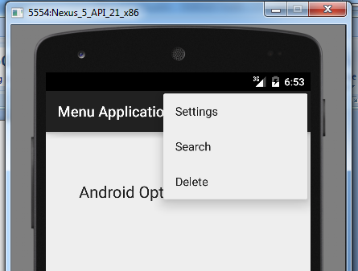

1. Click on any of the options menu items and you will be able to see the Toast message as below:

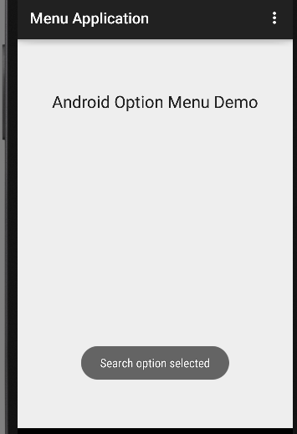

In the above exercise we are successfully build an app which demonstrates the options menu without icon.

1. Now modify your “menu_option_menu.xml” file as below to see the **options menu with icon**.

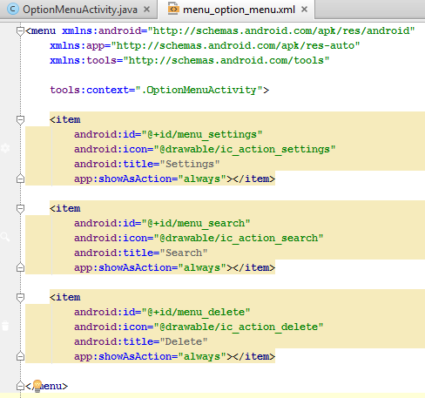

1. Now run your application and you will be able to see options menu with icons as described in the below snapshot:

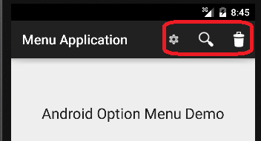

Assignment : Review the **Context Menu** and **Popup Menu** examples available in github folder and build your own sample application which demonstrates these features.

Dialogues: